23AI2003 –Artificial Intelligence for Web Development Lab
URK23CS5003

Ex. No: 4 | JavaScript – Dom Elements And Events

Aim

To create a web page which demonstrates dynamic actions for user interactions using

JavaScript document object model methods and events.

Description

Document Object Model:

A Document object represents the HTML document that is displayed in that window. The Document object has various properties that refer to other objects which allow access to and modification of document content. The way a document content is accessed and modified is called the Document Object Model, or DOM.

Finding HTML Element by Id

var myElement = document.getElementById("intro");

Finding HTML Elements by Tag Name

var x = document.getElementsByTagName("p");

Finding HTML Elements by Class Name

var x = document.getElementsByClassName("intro");

Finding HTML Elements by CSS Selectors

var x = document.querySelectorAll("p.intro");

Attach event handler to the document

document.addEventListener("click", function()

{

document.getElementById("demo").innerHTML = "Karunya";

});

JavaScript Events:

JavaScript's interaction with HTML is handled through events that occur when the user or the

browser manipulates a page.

Code
<!DOCTYPE html>
<html lang="en">
<head>
<meta charset="UTF-8">
<title>Music Concert DOM & Events</title>
<meta name="viewport" content="width=device-width, initial-scale=1.0">

<style>
body {
font-family: Arial, sans-serif;
background: #f4f6f8;
margin: 0;
padding: 20px;
}

h2 {
text-align: center;
color: #1f2933;
}

.container {
max-width: 900px;
margin: auto;
background: white;
padding: 20px;
border-radius: 8px;
}

.box {
border: 1px solid #ccc;
padding: 15px;
margin-bottom: 20px;
border-radius: 6px;
}

label {
font-weight: bold;
}

input, select, button {
width: 100%;
padding: 8px;
margin: 8px 0;
}

button {
background: #2563eb;
color: white;
border: none;
cursor: pointer;
}

button:hover {
background: #1d4ed8;
}

.result {
background: #e5e7eb;
padding: 10px;
margin-top: 10px;
font-weight: bold;
}

@media (max-width: 600px) {
body {
padding: 10px;
}
}
</style>
</head>

<body onload="pageLoaded()">

<h2>MUSIC CONCERT – JavaScript DOM & Events</h2>

<div class="container">

<!-- TC01, TC02, TC03: DOM Access -->
<div class="box">
<p id="intro">Welcome to DOM Experiment</p>
<p class="demo">Paragraph 1</p>
<p class="demo">Paragraph 2</p>

<button onclick="changeText()">Change Text</button>
</div>

<!-- TC04, TC08: onclick & Calculation -->
<div class="box">
<h3>Simple Calculator (onclick)</h3>

<input type="number" id="num1" placeholder="Enter first number">
<input type="number" id="num2" placeholder="Enter second number">

<button onclick="calculate()">Calculate</button>

<div class="result" id="calcResult">Result:</div>
</div>

<!-- TC04, TC07, TC08: onkeyup & DOM update -->
<div class="box">
<h3>BMI Calculator (onkeyup)</h3>

<input type="number" id="weight" placeholder="Weight (kg)" onkeyup="calculateBMI()">
<input type="number" id="height" placeholder="Height (cm)" onkeyup="calculateBMI()">

<div class="result" id="bmiResult">BMI:</div>
</div>

<!-- TC05: onchange -->
<div class="box">
<h3>Currency Converter (onchange)</h3>

<input type="number" id="amount" placeholder="Enter amount">
<select id="currency" onchange="convertCurrency()">
<option value="">Select Currency</option>
<option value="80">USD to INR</option>
<option value="90">EUR to INR</option>
<option value="100">GBP to INR</option>
<option value="1">INR to INR</option>
</select>

<div class="result" id="currencyResult">Converted Amount:</div>
</div>

<!-- TC05: onsubmit -->
<div class="box">
<h3>Form Submission (onsubmit)</h3>

<form onsubmit="return submitForm()">
<input type="text" id="username" placeholder="Enter your name">
<button type="submit">Submit</button>
</form>

<div class="result" id="formResult"></div>
</div>

</div>

<script>
/* TC06: onload */
function pageLoaded() {
document.getElementById("intro").innerHTML += " (Page Loaded)";
}

function changeText() {
document.getElementById("intro").style.color = "blue";

let items = document.getElementsByClassName("demo");
for (let i = 0; i < items.length; i++) {
items[i].innerHTML = "Updated using Class Name";
}

let tags = document.getElementsByTagName("p");
tags[0].style.fontWeight = "bold";
}

/* TC04, TC08 */
function calculate() {
let a = parseFloat(document.getElementById("num1").value);
let b = parseFloat(document.getElementById("num2").value);
let result = a + b;

document.getElementById("calcResult").innerHTML = "Result: " + result;
}

/* TC04, TC07, TC08 */
function calculateBMI() {
let w = document.getElementById("weight").value;
let h = document.getElementById("height").value / 100;

if (w && h) {
let bmi = (w / (h * h)).toFixed(2);
let status = "Normal";

if (bmi < 18) status = "Underweight";
else if (bmi >= 25 && bmi < 30) status = "Overweight";
else if (bmi >= 30) status = "Obese";

document.getElementById("bmiResult").innerHTML =
"BMI: " + bmi + " (" + status + ")";
}
}

/* TC05 */
function convertCurrency() {
let amount = document.getElementById("amount").value;
let rate = document.getElementById("currency").value;

if (amount && rate) {
document.getElementById("currencyResult").innerHTML =
"Converted Amount: " + (amount * rate);
}
}

/* TC05 */
function submitForm() {
let name = document.getElementById("username").value;
document.getElementById("formResult").innerHTML =
"Form submitted by " + name;
return false; // prevent reload
}
</script>

</body>
</html>

Input & Output
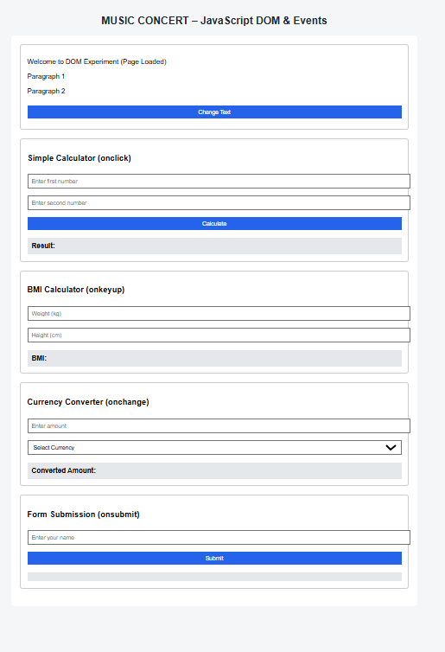

Result
The experiment was successfully completed.

